Session-5

1).Create two tables in SQL: influencers (with influencer_id as PRIMARY KEY and name) and posts (with post_id as PRIMARY KEY, influencer_id as FOREIGN KEY, and caption). Insert at least 3 influencers and 2 posts for each influencer.

Ans) CREATE TABLE influencers (
influencer_id INT PRIMARY KEY,
name VARCHAR(100)
);
CREATE TABLE posts (
post_id INT PRIMARY KEY,
influencer_id INT,
caption VARCHAR(255),
FOREIGN KEY (influencer_id) REFERENCES influencers(influencer_id)
);
INSERT INTO influencers (influencer_id, name)
VALUES
(1, 'CarryMinati'),
(2, 'Bhuvan Bam'),
(3, 'Prajakta Koli'),
(4, 'Ashish Chanchlani');
INSERT INTO posts (post_id, influencer_id, caption)
VALUES
(101, 1, 'New gaming video is live!'),
(102, 1, 'Thank you for 40M subscribers!'),
(103, 2, 'Behind the scenes of my latest vlog.'),
(104, 2, 'New music coming soon!'),
(105, 3, 'Daily motivation for everyone.'),
(106, 3, 'Travel diaries begin!');

Output:
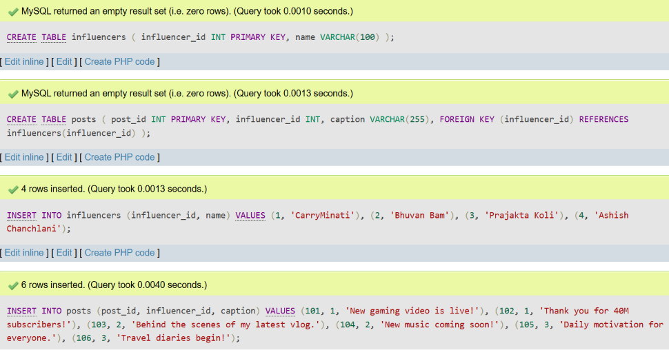

2).Write an SQL query using INNER JOIN to display each post's caption along with the name of the influencer who posted it, based on the tables you created.

Ans) SELECT
p.caption,
i.name
FROM posts p
INNER JOIN influencers i
ON p.influencer_id = i.influencer_id;

Output:
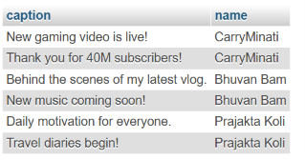

3).Write an SQL query using LEFT JOIN to show all influencers and their posts, including influencers who haven't posted anything yet. If an influencer has no posts, display 'No Posts' in the caption column.<br><br><em><strong>Hint:</strong> Use IFNULL or COALESCE to handle NULL values in the result.</em>

Ans) SELECT
i.name,
IFNULL(p.caption, 'No Posts') AS caption
FROM influencers i
LEFT JOIN posts p
ON i.influencer_id = p.influencer_id;

Output:
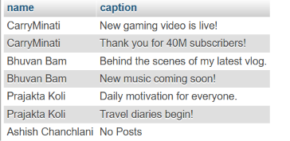

4).Write an SQL query using RIGHT JOIN to list all posts and the corresponding influencer's name, ensuring that even posts without a matching influencer_id (if any) are shown.

Ans). SELECT
p.post_id,
p.caption,
i.name
FROM influencers i
RIGHT JOIN posts p
ON i.influencer_id = p.influencer_id;

Output:-
